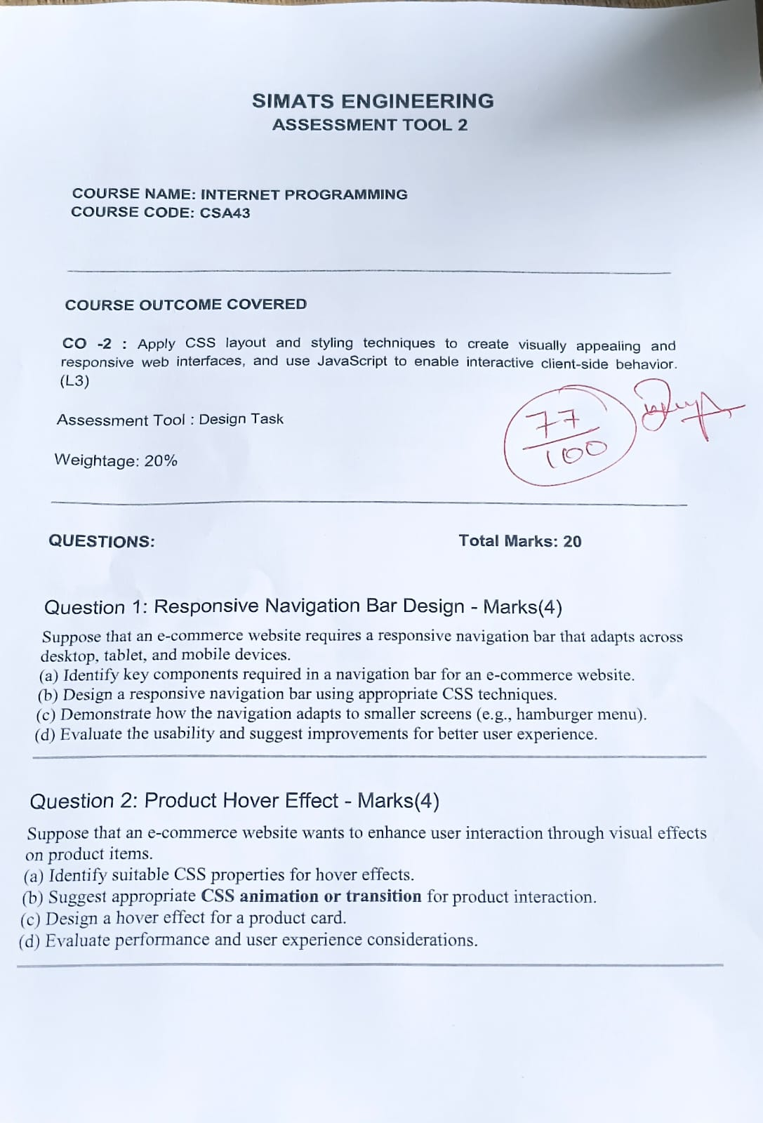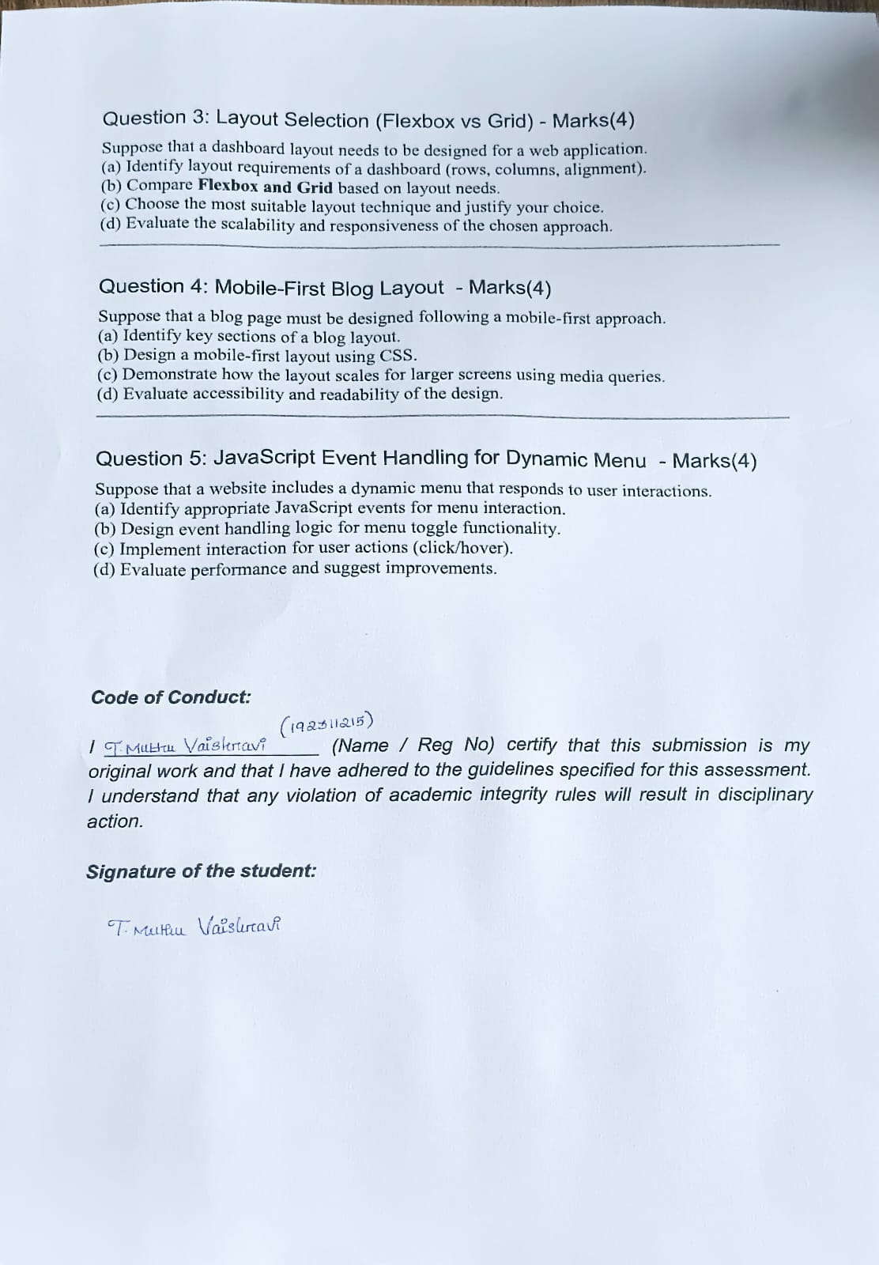
SIMATS ENGINEERING
ASSESSMENT TOOL 2
COURSE NAME: INTERNET PROGRAMMING
COURSE CODE: CSA43
COURSE OUTCOME COVERED: CO-2: Apply CSS layout and styling techniques to create visually appealing and responsive web interfaces, and use JavaScript to enable interactive client-side behavior. (L3)
Assessment Tool: Design Task Weightage: 20% Total Marks: 20

STUDENT DETAILS
Name: | T.MUTHU VAISHNAVI
Register Number: | 192311215
Course Name: | Internet Programming
Course Code: | CSA43
Assessment Tool: | Assessment Tool 2 – Design Task
Course Outcome: | CO2

Question 1: Responsive Navigation Bar Design - Marks(4)

Suppose that an e-commerce website requires a responsive navigation bar that adapts across desktop, tablet, and mobile devices.

Identify key components required in a navigation bar for an e-commerce website.
A comprehensive e-commerce navigation bar serves as the primary visual portal and user routing control center. To maximize user conversion and seamless browsing, the following key components are required:
  - Brand Logo & Identity Header: Placed at the top-left section, serving as brand anchor and immediate direct hyperlink to the store's homepage.
  - Categorical Navigation Links: Primary links providing access to main store departments (e.g., Home, Shop, Categories, Deals, Contact).

  - Product Search Bar: A prominent input field with a search icon/button enabling users to query the inventory directly.
  - User Utility & Cart Module: Quick access icons for user account settings, wishlist, and shopping cart equipped with a dynamic item counter badge.
  - Responsive Hamburger Menu Button: A compact three-bar icon displayed on mobile screen sizes to open and close collapsible vertical navigation drawers.

Design a responsive navigation bar using appropriate CSS techniques.
- Demonstrate how the navigation adapts to smaller screens (e.g., hamburger menu).

Short Explanation:
The solution utilizes CSS Flexbox for horizontal alignment across desktop viewports. Media
queries ( ) dynamically transform the horizontal bar into a
@media (max-width: 768px)
collapsible vertical menu on mobile screens. JavaScript handles the click event on the
active

hamburger icon, toggling an

Complete Source Code:
CSS class to reveal or hide navigation links smoothly.

<!DOCTYPE html>
<html lang="en">
<head>
<meta charset="UTF-8">
<meta name="viewport" content="width=device-width, initial-scale=1.0">
<title>E-Commerce Responsive Navigation Bar</title>
<style>
* { box-sizing: border-box; margin: 0; padding: 0; font-family: 'Times New Roman', Times, serif; }
body { background-color: #f4f6f9; }

/* Navigation Container */
.navbar {
display: flex;
justify-content: space-between;
align-items: center;
background-color: #1a252f;
padding: 14px 28px;
color: #ffffff;
position: relative;
box-shadow: 0 4px 6px rgba(0, 0, 0, 0.1);
}

.logo { font-size: 22px; font-weight: bold; color: #00bcd4; text-decoration: none; }

/* Search Box */
.search-box { display: flex; align-items: center; flex: 0 1 280px; margin: 0 15px; }
.search-box input {
width: 100%; padding: 7px 10px; border: 1px solid #ccc; border-radius: 4px 0 0 4px; outline: none;
}
.search-box button {
padding: 7px 12px; background-color: #00bcd4; border: none; color: #ffffff;
border-radius: 0 4px 4px 0; cursor: pointer; font-weight: bold;
}

/* Navigation Links */
.nav-links { display: flex; list-style: none; gap: 20px; align-items: center; }
.nav-links a { color: #ffffff; text-decoration: none; font-size: 15px; transition: color 0.3s; }
.nav-links a:hover { color: #00bcd4; }

/* Cart Badge */
.cart-badge { background-color: #e74c3c; color: #ffffff; padding: 2px 6px; border-radius: 10px; font-size: 11px; margin-left: 4px; }

/* Hamburger Menu Toggle */
.hamburger { display: none; flex-direction: column; cursor: pointer; gap: 4px; }
.hamburger span { width: 24px; height: 3px; background-color: #ffffff; border-radius: 2px; }

/* Tablet and Mobile Screen Styles */
@media (max-width: 768px) {
.search-box { display: none; }
.hamburger { display: flex; }
.nav-links {
position: absolute; top: 100%; left: 0; width: 100%;
background-color: #1a252f; flex-direction: column;
align-items: center; padding: 18px 0; gap: 14px; display: none;
box-shadow: 0 4px 8px rgba(0,0,0,0.2);
}
.nav-links.active { display: flex; }
}
</style>
</head>
<body>

<nav class="navbar">
<a href="#" class="logo">E-Store</a>
<div class="search-box">
<input type="text" placeholder="Search product...">
<button type="button">Search</button>
</div>
<ul class="nav-links" id="navLinks">
<li><a href="#">Home</a></li>
<li><a href="#">Shop</a></li>
<li><a href="#">Categories</a></li>
<li><a href="#">Deals</a></li>
<li><a href="#">Cart <span class="cart-badge">3</span></a></li>
</ul>
<div class="hamburger" id="hamburger" onclick="toggleMenu()">
<span></span><span></span><span></span>
</div>
</nav>

<script>
function toggleMenu() {
document.getElementById('navLinks').classList.toggle('active');
}
</script>
</body>
</html>

Output & Browser Screenshots:

http://localhost:8080/index.html — Google Chrome (Desktop View - 1024px)
Home Shop
E-Store
Categories
Search
Deals
Cart 3
Figure 1: Responsive Navigation Bar
http://localhost:8080/index.html Mobile View
—
Home Shop Categories Deals
Cart 3
E-Store
Figure 2: Mobile Navigation

Evaluate the usability and suggest improvements for better user experience.
Usability Evaluation: The Flexbox layout maintains consistent spatial distribution across high-resolution desktop screens, while the mobile drawer hides dense navigational options, keeping the interface uncluttered on mobile devices.

UX & Accessibility Improvements:
  - ARIA Accessibility: Add and
aria-expanded="false"
aria-label="Toggle

to the hamburger toggle for screen reader compatibility.
navigation menu"
  - Sticky Navigation: Apply
position: sticky; top: 0; z-index: 1000;
navigation accessible during vertical page scrolling.

to keep

  - Mobile Search Modal: Replace the hidden search bar on mobile screens with a search icon that triggers a full-width popup search modal.

Question 2: Product Hover Effect - Marks(4)

Suppose that an e-commerce website wants to enhance user interaction through visual effects on product items.

Identify suitable CSS properties for hover effects.
Interactive CSS hover effects improve affordance and visual engagement. Key CSS properties include:

•
transform
and scaling (
•
transition
: Executes smooth geometric shifts such as elevation (
).
translateY(-8px)
scale(1.05)
: Specifies the duration, timing curve (e.g.,
ease-in-out
)

), and delay for

property state changes.
- : Increases drop-shadow blur and spread to simulate elevation in 3D space on hover.
box-shadow
- : Controls smooth fading of hidden overlay controls, such as "Quick View" or "Add to Cart" buttons.
opacity
- : Applies dynamic visual filters like brightness or blur adjustment to featured product imagery.
filter

Suggest appropriate CSS animation or transition for product interaction.
Recommendation: CSS Transitions using GPU-accelerated properties (
transform
) are optimal. Using a cubic-bezier timing function (
opacity
transition: transform

and

) produces smooth, 60fps animations. This avoids trigger layout reflows associated with animating dimensions
0.3s cubic-bezier(0.25, 0.8, 0.25, 1), box-shadow 0.3s ease
like or .
height
margin

Design a hover effect for a product card.

Short Explanation:
The product card elevates upward on hover via ,
transform: translateY(-8px)
accompanied by a soft drop shadow expansion. Simultaneously, the product icon scales slightly and an "Add to Cart" button slides up into view from the bottom overlay container.

Complete Source Code:

<!DOCTYPE html>
<html lang="en">
<head>
<meta charset="UTF-8">
<meta name="viewport" content="width=device-width, initial-scale=1.0">
<title>Product Card Hover Effect</title>
<style>
body {
font-family: 'Times New Roman', Times, serif;
background-color: #f1f5f9;
display: flex; justify-content: center; align-items: center;
min-height: 100vh; margin: 0;
}

/* Product Card Container */
.product-card {
width: 260px; background: #ffffff; border-radius: 10px;
overflow: hidden; box-shadow: 0 4px 10px rgba(0, 0, 0, 0.08);
transition: transform 0.3s ease, box-shadow 0.3s ease;
cursor: pointer; position: relative;
}

/* Card Elevation on Hover */
.product-card:hover {
transform: translateY(-8px);
box-shadow: 0 12px 22px rgba(0, 0, 0, 0.18);
}

.image-box {
width: 100%; height: 180px; background-color: #e2e8f0;
display: flex; justify-content: center; align-items: center;
position: relative; overflow: hidden;
}
.product-icon { font-size: 56px; transition: transform 0.4s ease; }
.product-card:hover .product-icon { transform: scale(1.12); }

/* Action Button Overlay */
.cart-btn {
position: absolute; bottom: 12px; left: 50%;
transform: translateX(-50%) translateY(30px);
background-color: #00bcd4; color: #ffffff;
padding: 8px 16px; border: none; border-radius: 20px;
font-weight: bold; opacity: 0; transition: all 0.3s ease;
}

.product-card:hover .cart-btn {
opacity: 1; transform: translateX(-50%) translateY(0);
}


.card-body { padding: 15px; }
.category { font-size: 11px; color: #64748b; text-transform: uppercase; }
.title { font-size: 16px; font-weight: bold; margin: 5px 0; color: #1e293b; }
.price { font-size: 15px; color: #e74c3c; font-weight: bold; }
</style>
</head>
<body>

<div class="product-card">
<div class="image-box">
<div class="product-icon"> </div>
<button class="cart-btn">Add to Cart</button>
</div>
<div class="card-body">
<div class="category">Electronics</div>
<div class="title">Wireless Headphones</div>
<div class="price">$129.99</div>
</div>
</div>

</body>
</html>

Output & Browser Screenshots:



http://localhost:8080/product.html — Hover Effect State Comparison

ELECTRONICS
Wireless Headphones
$129.99

State: Before Hover
ELECTRONICS
Wireless Headphones
$129.99

State: After Hover

Figure 3: Product Hover Effect

Evaluate performance and user experience considerations.
Performance Considerations: Animating composite properties (
transform

and

) offloads rendering to the GPU, avoiding expensive layout recalculations and
opacity
repaints.

User Experience Considerations:
  - Touch Device Compatibility: Hover effects are unavailable on mobile touchscreens. Essential functionality like "Add to Cart" should remain accessible without requiring hover.
  - Accessibility (Reduced Motion): Include a
@media (prefers-reduced-motion:
query to disable intensive animations for users sensitive to motion.
reduce)

Question 3: Layout Selection (Flexbox vs Grid) - Marks(4)

Suppose that a dashboard layout needs to be designed for a web application.

Identify layout requirements of a dashboard (rows, columns, alignment).
An enterprise dashboard requires a structured two-dimensional architecture comprising:
  - Header Bar (Row 1): Full-width container holding titles, search input, and profile details.
  - Sidebar Panel (Column 1): Vertical navigation column for application routing.
  - KPI Summary Grid (Multi-Column Row): Responsive cards displaying key metrics with consistent alignment.
  - Analytics Content Panels (Multi-Row/Multi-Column Grid): Data visualization charts and system logs matching heights across grid tracks.

Compare Flexbox and Grid based on layout needs.

Feature /  Criteria | CSS Flexbox | CSS Grid Layout
Layout Dimension | One-Dimensional (Rows OR Columns). | Two-Dimensional (Rows AND Columns simultaneously).
Design Approach | Content-driven (items size based on inner content). | Layout-driven (content fits into defined tracks).
Grid Track Alignment | Requires complex item width percentages. | Native track control with grid-template-columns .
Dashboard Role | Micro-layouts (card content, button groups). | Macro-layouts (overall dashboard layout scaffold).

Choose the most suitable layout technique and justify your choice.
Selected Strategy: Hybrid Approach (CSS Grid Macro Scaffold + CSS Flexbox Micro Alignment).
Justification: CSS Grid manages two-dimensional structural areas (sidebar, header, content
grid) cleanly using . Within individual widgets, CSS Flexbox
grid-template-areas
handles one-dimensional alignment of icons, labels, and action buttons.

Evaluate the scalability and responsiveness of the chosen approach.

Short Explanation:
CSS Grid uses to automatically adjust KPI
repeat(auto-fit, minmax(220px, 1fr))
widget counts per row according to available screen width without requiring extra media queries.

Complete Source Code:

<!DOCTYPE html>
<html lang="en">
<head>
<meta charset="UTF-8">
<meta name="viewport" content="width=device-width, initial-scale=1.0">
<title>Web Application Dashboard Layout</title>
<style>
* { box-sizing: border-box; margin: 0; padding: 0; font-family: 'Times New Roman', serif; }
body { background-color: #f1f5f9; }

/* Dashboard Grid Container */
.dashboard-container {
display: grid;
grid-template-columns: 220px 1fr;
grid-template-rows: 60px 1fr;
grid-template-areas:
"sidebar header"
"sidebar main";
min-height: 100vh;
}

.header { grid-area: header; background: #ffffff; padding: 0 20px; display: flex; align-items: center; justify-content: space-between; border-bottom: 1px solid #e2e8f0; }
.sidebar { grid-area: sidebar; background: #0f172a; color: #ffffff; padding: 20px; }
.sidebar h2 { color: #38bdf8; font-size: 18px; margin-bottom: 20px; }
.sidebar li { list-style: none; margin-bottom: 12px; }
.sidebar a { color: #cbd5e1; text-decoration: none; }

.main-content { grid-area: main; padding: 20px; }

/* Scalable Responsive KPI Grid */
.widgets-grid {
display: grid;
grid-template-columns: repeat(auto-fit, minmax(200px, 1fr));
gap: 15px; margin-bottom: 20px;
}

.card { background: #ffffff; padding: 15px; border-radius: 6px; box-shadow: 0 2px 4px rgba(0,0,0,0.05); }
.card h4 { color: #64748b; font-size: 13px; }
.card .val { font-size: 22px; font-weight: bold; color: #0f172a; margin-top: 5px; }

.panel-grid { display: grid; grid-template-columns: 2fr 1fr; gap: 15px; }
.panel { background: #ffffff; padding: 15px; border-radius: 6px;

min-height: 150px; }

@media (max-width: 768px) {
.dashboard-container { grid-template-columns: 1fr; grid-template-rows: auto auto 1fr; grid-template-areas: "header" "sidebar" "main"; }
.panel-grid { grid-template-columns: 1fr; }
}
</style>
</head>
<body>

<div class="dashboard-container">
<header class="header">
<h3>Admin Dashboard</h3>
<div>User: Sameera Banu</div>
</header>

<aside class="sidebar">
<h2>Analytics</h2>
<ul>
<li><a href="#">Overview</a></li>
<li><a href="#">Sales</a></li>
<li><a href="#">Settings</a></li>
</ul>
</aside>

<main class="main-content">
<div class="widgets-grid">
<div class="card"><h4>Total Revenue</h4><div class="val">$45,230</div></div>
<div class="card"><h4>New Users</h4><div class="val">+1,205</ div></div>
<div class="card"><h4>Active Sessions</h4><div class="val">432</div></div>
<div class="card"><h4>Conversion</h4><div class="val">3.2%</ div></div>
</div>

<div class="panel-grid">
<div class="panel"><h4>Sales Performance Chart</h4><p style="color:#64748b; font-size:12px; margin-top:10px;">[ Dynamic Graph Output ]</p></div>
<div class="panel"><h4>System Activity</h4><p style="color:#64748b; font-size:12px; margin-top:10px;">[ Real-time Activity Logs ]</p></div>
</div>
</main>
</div>

</body>
</html>

Output & Browser Screenshots:
http://localhost:8080/dashboard.html — Dashboard Layout Output
Analytics
Admin Dashboard
User: Sameera Banu
- Overview
- Sales
- Customers
- Settings
Revenue
$45,230
New Users
+1,205
Sessions
432
Conversion
3.2%
Sales Performance Chart
System Log
- User login at 14:02
- Backup completed

[ Visual Analytics Data ]
Figure 4: Dashboard Layout

Question 4: Mobile-First Blog Layout - Marks(4)

Suppose that a blog page must be designed following a mobile-first approach.

Identify key sections of a blog layout.
A standard mobile-first blog architecture requires structural separation across four core sections:
  - Header & Navigation Banner: Displays blog title, tagline, and navigation bar.
  - Main Article Container: Contains the post headline, metadata (author, date), hero banner image, and structured body paragraphs.
  - Sidebar Panel: Displays author biography, post categories, search input, and social sharing icons.
  - Footer: Displays copyright notices, RSS links, and legal terms.

Design a mobile-first layout using CSS.
- Demonstrate how the layout scales for larger screens using media queries.

Short Explanation:
The mobile-first workflow styles base elements for narrow mobile displays first without
media queries. Progressive enhancement using expands the
@media (min-width: 1024px)

layout into a two-column desktop grid where the article occupies 3 fr units and the sidebar occupies 1 fr unit.

Complete Source Code:

<!DOCTYPE html>
<html lang="en">
<head>
<meta charset="UTF-8">
<meta name="viewport" content="width=device-width, initial-scale=1.0">
<title>Mobile-First Blog Layout</title>
<style>
* { box-sizing: border-box; margin: 0; padding: 0; font-family: 'Times New Roman', serif; }
body { background-color: #fafafa; color: #333333; line-height:
1.6; }

.header { background-color: #2c3e50; color: #ffffff; padding: 20px; text-align: center; }

.container { width: 92%; margin: 20px auto; display: flex; flex-direction: column; gap: 20px; }

.main-article { background: #ffffff; padding: 18px; border-radius: 6px; box-shadow: 0 2px 5px rgba(0,0,0,0.05); }
.hero-img { width: 100%; height: 180px; background-color: #cbd5e1; border-radius: 4px; display: flex; align-items: center; justify-content: center; color: #475569; margin-bottom: 15px; }

.sidebar { background: #ffffff; padding: 18px; border-radius: 6px; box-shadow: 0 2px 5px rgba(0,0,0,0.05); }

.footer { background: #2c3e50; color: #ffffff; text-align: center; padding: 12px; margin-top: 20px; font-size: 13px; }

/* Desktop Scaling */
@media (min-width: 1024px) {
.container { display: grid; grid-template-columns: 3fr 1fr; max-width: 1000px; }
}
</style>
</head>
<body>

<header class="header">
<h1>Tech Insights Blog</h1>
<p style="font-size:13px;">Exploring Web Architecture & Modern CSS</p>
</header>

<div class="container">
<main class="main-article">
<div class="hero-img">[ Featured Hero Image ]</div>
<h2>Building Responsive Web Applications Mobile-First</h2>
<p style="font-size:12px; color:#666; margin-bottom:10px;">By

Sameera Banu | Published July 2026</p>
<p>Designing mobile-first guarantees optimized performance and clean visual layout structures across constrained viewports before scaling up to desktop displays...</p>
</main>

<aside class="sidebar">
<h3>About Author</h3>
<p style="font-size:13px; margin-top:5px;">Sameera Banu. P — Web Developer.</p>
<h3 style="margin-top:15px;">Categories</h3>
<ul style="font-size:13px; margin-left:15px; margin-top:5px;">
<li>CSS Grid & Flexbox</li>
<li>JavaScript Logic</li>
</ul>
</aside>
</div>

<footer class="footer">
<p>&copy; 2026 Tech Insights. All Rights Reserved.</p>
</footer>

</body>
</html>

Output & Browser Screenshots:
http://localhost:8080/blog.html Comparison
—
Mobile vs Desktop Blog Layout
About Author
[ Hero Banner ]
[ Hero Banner ]
Sameera Banu
Mobile-First Web Design
Content stacked vertically in a single column for mobile devices.
Categories
- CSS Grid Building Responsive Web Applications Mobile- • JavaScript First
Multi-column grid expansion utilizing desktop width...
Sidebar: Author & Categories stacked below
article.
Tech Insights (Desktop View - 1024px Grid)
Tech Insights (Mobile)

Figure 5: Blog Layout

Evaluate accessibility and readability of the design.
Readability Evaluation: The layout restricts article max-width on wide displays, preserving an optimal reading line length of 60 to 75 characters per line. Line height is set to 1.6 for comfortable body paragraph scanning.
Accessibility Standards: Uses structural HTML5 landmarks ( , ,
<header>
<main>
<article>
<aside>
<footer>

efficiently.
,
,
) to allow screen readers to navigate content regions

Question 5: JavaScript Event Handling for Dynamic Menu - Marks(4)
Suppose that a website includes a dynamic menu that responds to user interactions.

Identify appropriate JavaScript events for menu interaction.
To implement interactive client-side menus, the following DOM events are essential:
  - : Triggers dynamic toggling of dropdown visibility on touch and desktop screens.
click
mouseleave

  - ​
mouseenter
devices.
keydown
/
: Handles hover-triggered dropdown expansion on desktop

  - ​
Escape
blur
: Intercepts keyboard navigation (e.g., closing open dropdown menus when the key is pressed).

  - ​
focusout
away.
/
: Automatically closes open submenus when keyboard focus shifts

Design event handling logic for menu toggle functionality.

- Implement interaction for user actions (click/hover).

Short Explanation:
The implementation combines mouse hover events (
mouseenter

/

) for
mouseleave

desktop interactions with event listeners for mobile devices and keyboard
click
accessibility. An outside click handler closes active dropdowns when clicking elsewhere on the page.

Complete Source Code:

<!DOCTYPE html>
<html lang="en">
<head>
<meta charset="UTF-8">
<meta name="viewport" content="width=device-width, initial-scale=1.0">
<title>Dynamic Interactive Menu</title>
<style>
* { box-sizing: border-box; margin: 0; padding: 0; font-family: 'Times New Roman', serif; }
body { background-color: #f8fafc; padding: 30px; }

.menu-bar { background-color: #1e293b; display: flex; border-radius: 6px; list-style: none; padding: 0 10px; }
.menu-item { position: relative; }
.menu-link { display: block; padding: 12px 18px; color: #ffffff; text-decoration: none; cursor: pointer; }
.menu-link:hover, .menu-item.show > .menu-link { background-color: #334155; color: #38bdf8; }

/* Submenu Panel */
.submenu {
display: none; position: absolute; top: 100%; left: 0;
background-color: #334155; min-width: 160px;
box-shadow: 0 4px 8px rgba(0,0,0,0.15); border-radius: 0 0 6px 6px; list-style: none;
}
.submenu a { display: block; padding: 10px 14px; color: #ffffff; text-decoration: none; font-size: 13px; }
.submenu a:hover { background-color: #475569; color: #38bdf8; }

.menu-item.show .submenu { display: block; }
</style>
</head>
<body>

<ul class="menu-bar">
<li class="menu-item"><a class="menu-link" href="#">Home</a></li>
<li class="menu-item dropdown">
<a class="menu-link" href="#">Services ▾</a>
<ul class="submenu">
<li><a href="#">Web Development</a></li>
<li><a href="#">UI/UX Design</a></li>
<li><a href="#">Cloud Hosting</a></li>
</ul>
</li>
<li class="menu-item"><a class="menu-link" href="#">Contact</a></ li>
</ul>

<script>
document.addEventListener('DOMContentLoaded', () => { const dropdowns = document.querySelectorAll('.dropdown');

dropdowns.forEach(dropdown => {
// Toggle on click dropdown.addEventListener('click', function(e) {
e.stopPropagation();
dropdowns.forEach(item => { if(item !== dropdown) item.classList.remove('show'); });
this.classList.toggle('show');
});

// Hover support for desktop dropdown.addEventListener('mouseenter', function()
{ this.classList.add('show'); }); dropdown.addEventListener('mouseleave', function()
{ this.classList.remove('show'); });
});

// Close on document click outside document.addEventListener('click', () => {
dropdowns.forEach(item => item.classList.remove('show'));
});

// Close on Escape key press document.addEventListener('keydown', (e) => {
if (e.key === 'Escape') dropdowns.forEach(item => item.classList.remove('show'));
});
});
</script>
</body>
</html>

Output & Browser Screenshots:

http://localhost:8080/dynamic-menu.html — Dynamic State Execution
Menu Before Click / Hover (Default State):
Home
Contact
Menu After Click / Active Hover (Expanded Dynamic Submenu):
Home
Contact

- Web Development

- UI/UX Design
- Cloud Hosting
Services ▾
Services ▾
Figure 6: Dynamic Menu

Evaluate performance and suggest improvements.
Performance Evaluation: Scoping event listeners to target dropdown containers prevents global listener overhead, minimizing CPU utilization during menu interaction.

Suggested Improvements:
  - Dynamic ARIA State Updates: Dynamically update on the trigger element when submenus open or close.
aria-expanded="true/false"
  - Keyboard Focus Trapping: Manage keyboard tab focus within expanded dropdown menus to enhance accessibility for assistive technology users.
CODE OF CONDUCT
I Sameera Banu. P / 192372172 certify that this submission is my original work and that I have adhered to the guidelines specified for this assessment. I understand that any violation of academic integrity rules will result in disciplinary action.

Signature of the student: Sameera Banu. P

RUBRICS FOR CALCULATION

Criteria | Weightage (%) | Level 4 –  Exemplary (4) | Level 3 –  Proficient (3) | Level 2 –  Developing (2) | Level 1 –  Beginning (1)
Understanding | 25 | Demonstrates | Good | Basic | Poor
of Concept |  | complete | understanding | understanding | understanding
 |  | understanding | with minor | with some | or incorrect
 |  | of design | gaps. | errors. | concepts.
 |  | requirements
 |  | and concepts.
Design / | 30 | Well-structured, | Correct | Basic | Incorrect or
Implementation |  | efficient, and | implementation | implementation | incomplete
 |  | responsive | with minor | with | implementation.
 |  | design | issues. | inconsistencies.
 |  | implementation.
Use of Tools | 20 | Effective and | Appropriate | Limited or | Incorrect or
(CSS/JS) |  | advanced use of | use of tools. | inconsistent | minimal use.
 |  | tools/ |  | use.
 |  | techniques.
Analysis & | 15 | Insightful | Good analysis | Basic analysis | Poor or no
Evaluation |  | analysis with | with | with limited | analysis.
 |  | strong | justification. | depth.
 |  | justification and
 |  | optimization.
Documentation / | 10 | Clear, well- | Mostly clear | Basic clarity, | Poor or unclear
Clarity |  | structured, and | with minor | missing details. | documentation.
 |  | properly | issues.
 |  | presented
 |  | solution.

